SID: 2363665

Week 1 - Lab Logbook Entry

This week, I explored different Pandas classes and found five of them particularly interesting:

1. **DataFrame** – This is like a supercharged table that organizes data in rows and columns. It makes it easy to analyze and manipulate structured data.
2. **Series** – A Series feels like a single-column spreadsheet, where each value has a label, makes it simple to work with individual data columns.
3. **Index** – The Index class acts like a built-in organizer. it helps to label and quickly access data in both rows and columns.
4. **DatetimeIndex** – Working with time-based data can be tricky, but this class makes handling dates and times smooth and efficient.
5. **Categorical** – Instead of storing repetitive text data inefficiently, this class groups similar values together, saves memory and speeds up operations.

Week 2 - Anomaly Detection and Regression

# Scatter plot between house size and cost

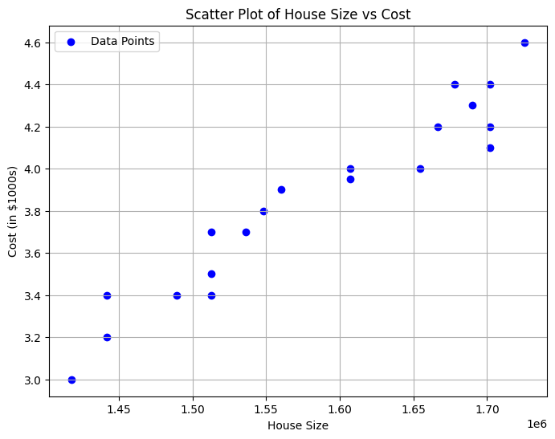

Estimated cost for house size 1772748.75: 4.6

Week 3 - Neural Networks and AI-Specific attacks

# Plot of anomalies using Z-score and IQR methods

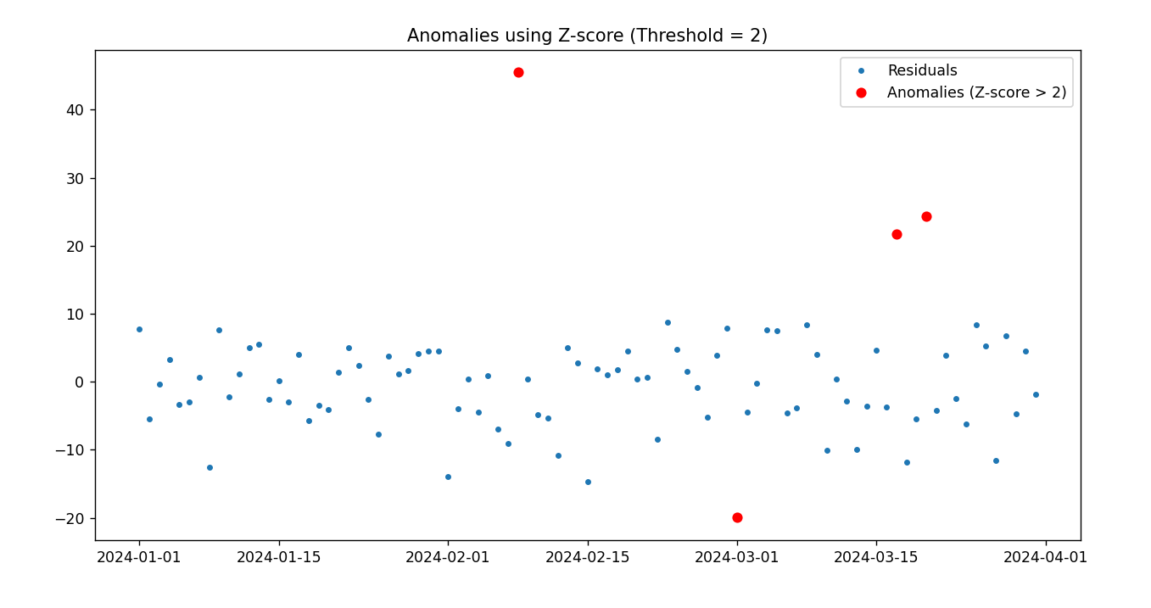

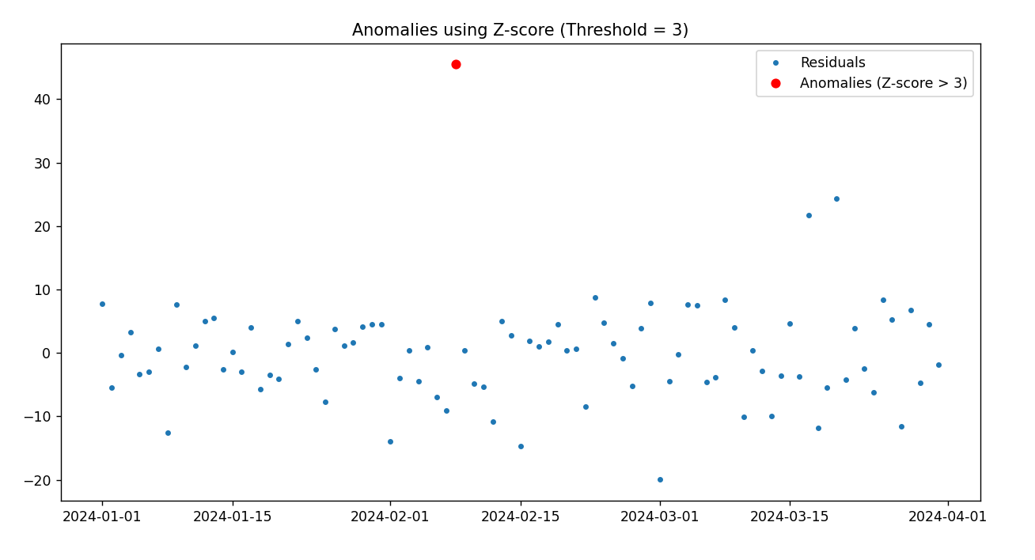

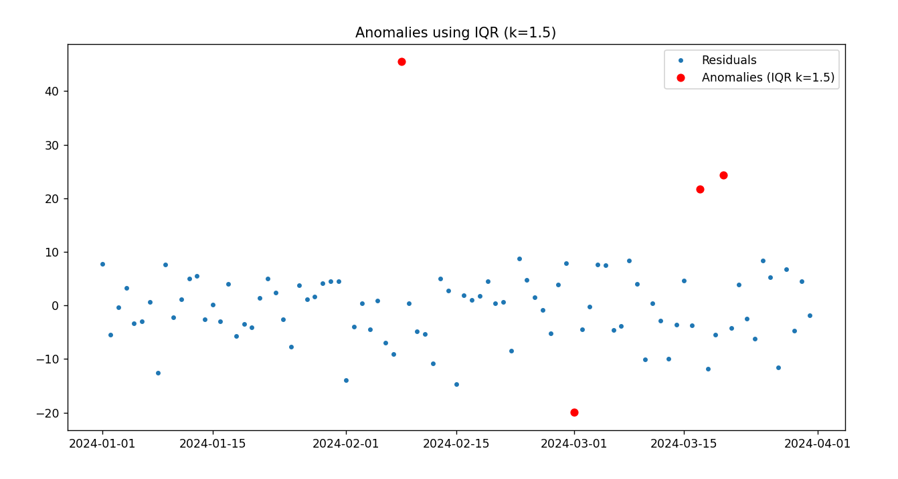

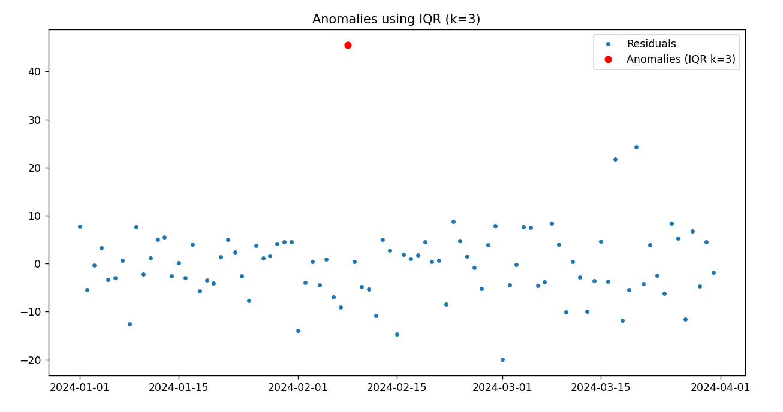

Week 4 - Lab Logbook Entry

# Plot a graph showing the model's accuracy for each epsilon value.

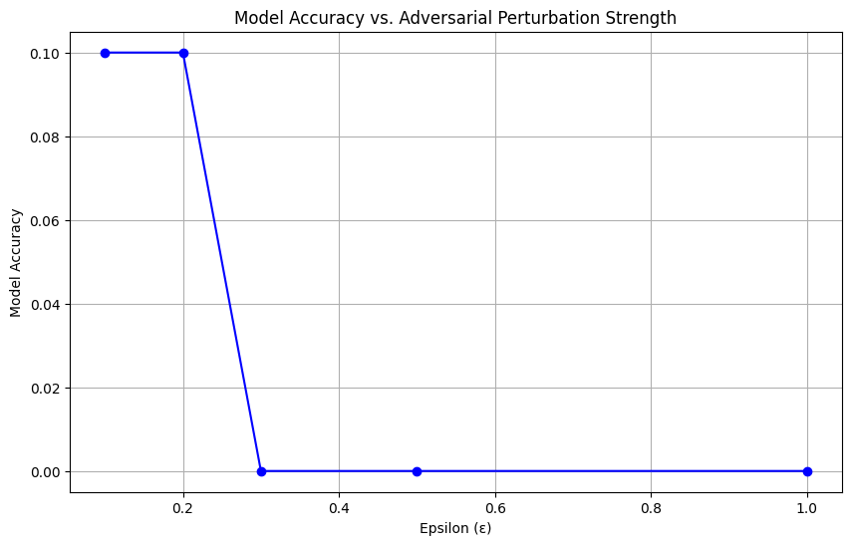

# The model accuracy before and after data poisoning.

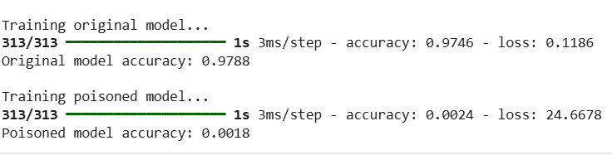

Week 5 - Lab Logbook Entry

My SID is 2363665. So, 65/2 is 32.5, used epoch 33(ceil it).

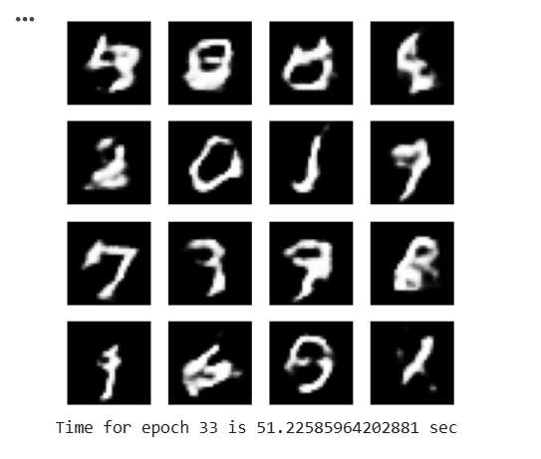

Week 6 - Lab Logbook Entry

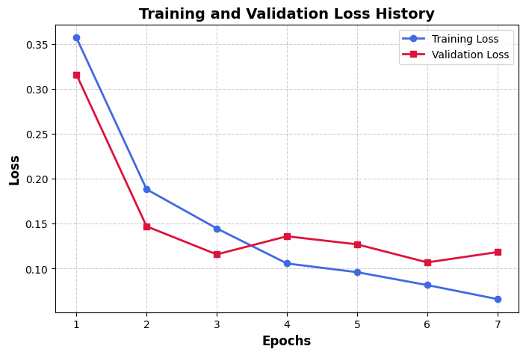

Week 7 - Lab Logbook Entry

1. **A. Sample of plain and cypher text for DES**

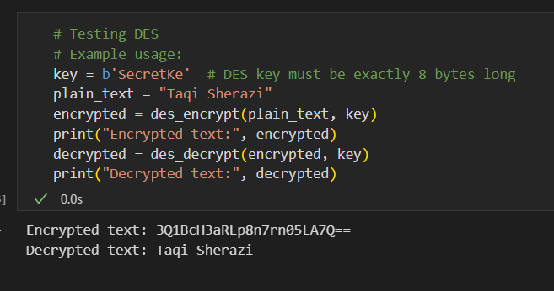

1. **B. Sample of plain and cypher text for AES**

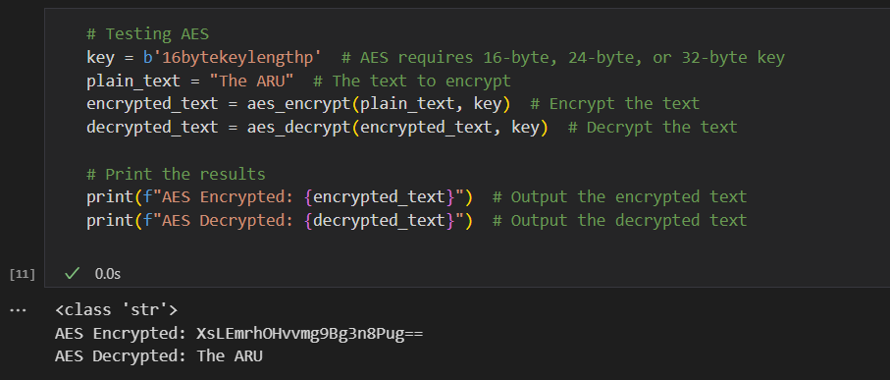

**2. Real image and cipher image for the image of any choice using AES**

Real Image Cipher Image

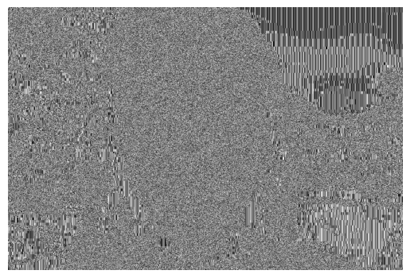

**3.Explain in one word 'YES' or 'NO' whether encryption method for the images is good.**

**No.** AES in ECB (Electronic Codebook) mode is not secure for encrypting images because identical plaintext blocks produce identical ciphertext blocks.